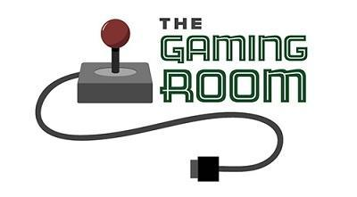

<The Gaming Room>

CS 230 Project Software Design Template
Version 1.0

Table of Contents

CS 230 Project Software Design Template 1
Table of Contents 2
Document Revision History 2
Executive Summary 3
Requirements 3
Design Constraints 3
System Architecture View 3
Domain Model 3
Evaluation 4
Recommendations 5

Document Revision History

Version | Date | Author | Comments
1.0 | <01/25/26> | <Daniel Urena> | <Brief description of changes in this revision>

Instructions
Fill in all bracketed information on page one (the cover page), in the Document Revision History table, and below each header. Under each header, remove the bracketed prompt and write your own paragraph response covering the indicated information.

Executive Summary

The Gaming Room is seeking to expand its existing Android based game, Draw It or Lose It, into a web based application capable of supporting multiple platforms. The main software design challenge is creating a scalable and maintainable system that supports multiple games, teams, and players while ensuring unique names and consistent game state management.

To address these needs, this project proposes a Java based application using object oriented design principles and established design patterns. A centralized service class will manage all games using the singleton pattern to ensure only one instance exists in memory. Unique identifiers will be assigned to all games, teams, and players, and name uniqueness will be enforced through controlled creation methods. This approach provides a solid foundation for future expansion while meeting the client’s current functional requirements.

Requirements

< Please note: While this section is not being assessed, it will support your outline of the design constraints below. In your summary, identify each of the client’s business and technical requirements in a clear and concise manner.>

Design Constraints

Developing the application in a web based distributed environment introduces several design constraints. Multiple users may access the system simultaneously, requiring careful management of shared resources such as game data and identifiers. This constraint influences the design by requiring a centralized service layer to manage game creation and retrieval consistently.

Network latency and reliability are also important constraints, as communication between clients and the server may be delayed or interrupted. As a result, the application must separate core game logic from the user interface to ensure reliability and flexibility. Additionally, scalability is a constraint, as the initial in memory implementation must be designed so it can later transition to persistent storage without major redesign. Security considerations, such as validating user input and protecting game data, also influence the design choices made in this application.

System Architecture View

Please note: There is nothing required here for these projects, but this section serves as a reminder that describing the system and subsystem architecture present in the application, including physical components or tiers, may be required for other projects. A logical topology of the communication and storage aspects is also necessary to understand the overall architecture and should be provided.

Domain Model

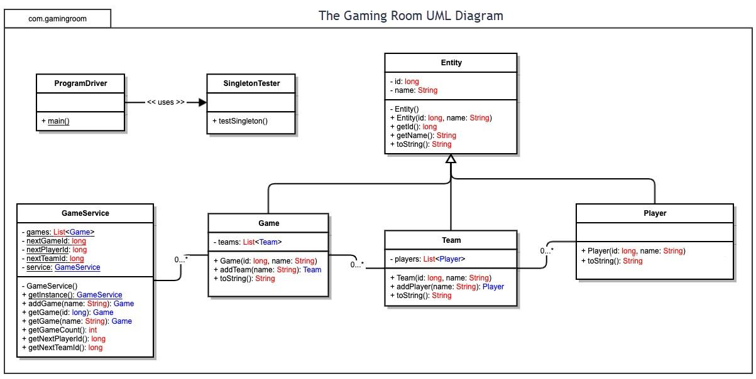

The UML class diagram represents the core structure of the Draw It or Lose It application and its domain model. At the foundation of the model is the Entity base class, which contains common attributes such as a unique identifier and a name. The Game, Team, and Player classes inherit from Entity, demonstrating inheritance and promoting code reuse.

The GameService class acts as the central manager for the application and is implemented using the singleton pattern to ensure only one instance exists in memory. It maintains a collection of Game objects and is responsible for assigning unique identifiers to games, teams, and players. Each Game object contains one or more Team objects, and each Team contains multiple Player objects, reflecting the required one to many relationships shown in the UML diagram.

The diagram demonstrates key object oriented programming principles, including inheritance, encapsulation, abstraction, and aggregation. These principles allow the application to efficiently enforce unique names, manage relationships between objects, and maintain a clean and extensible design that fulfills the client's software requirements.

Evaluation

Development Requirements | Mac | Linux | Windows | Mobile Devices
Server Side | Can host web servers via Apache, Nginx, or Node.js. Advantages: stable Unix-based system, strong developer tools. Weaknesses: higher hardware costs, less common in enterprise hosting. Licensing is mostly tied to hardware. | Excellent for web servers; supports Apache, Nginx, Node.js, Java. Advantages: free or low cost, scalable, secure, strong open-source support. Weaknesses: requires Linux expertise. | Supports IIS, Apache, Node.js. Advantages: familiar GUI, strong enterprise integration. Weaknesses: higher licensing costs, higher resource usage. | Not suitable for production hosting. Can run local development servers for testing. Weaknesses: limited CPU, memory, storage, and network reliability.
Client Side | Supports all major browsers and iOS testing via Xcode. Requires web development expertise. Advantages: strong Apple ecosystem. Weaknesses: cost of hardware and tools, additional testing effort. | Supports major browsers and mobile emulators. Advantages: low cost, flexible open-source tools. Weaknesses: higher technical expertise needed for setup and testing. | Supports all browsers and responsive web testing tools. Advantages: widely used, strong IDE support. Weaknesses: licensing costs, potential Unix compatibility issues. | Native testing for iOS (Xcode) and Android (Android Studio). Advantages: ensures device performance and responsive design. Weaknesses: multiple environments increase development time and complexity.
Development Tools | Languages: Java, JavaScript, HTML/CSS. IDEs: Xcode, VS Code, IntelliJ. Advantages: mature frameworks, ecosystem integration. Weaknesses: hardware and licensing costs. | Languages: Java, JavaScript, HTML/CSS. IDEs: VS Code, Eclipse, IntelliJ, Docker. Advantages: free, container support, flexible. Weaknesses: Linux administration expertise required. | Languages: Java, JavaScript, HTML/CSS, .NET (optional). IDEs: Visual Studio, VS Code, IntelliJ. Advantages: enterprise support, GUI tools. Weaknesses: licensing costs, higher system requirements. | Languages: Java (Android), Swift (iOS), JavaScript/HTML/CSS. IDEs: Android Studio, Xcode, React Native, Flutter. Advantages: native device support, cross-platform frameworks. Weaknesses: more complex, multiple environments, licensing for macOS/iOS.

Recommendations

Analyze the characteristics of and techniques specific to various systems architectures and make a recommendation to The Gaming Room. Specifically, address the following:

- Operating Platform: <Recommend an appropriate operating platform that will allow The Gaming Room to expand Draw It or Lose It to other computing environments.>
The recommended server platform for Draw It or Lose It is a Linux-based operating system. Linux supports multi-user and multitasking environments, which is necessary because the game must allow multiple instances to run simultaneously with different teams and players. A server-based Linux system can efficiently handle concurrent processes and manage network communication between clients and the server. Because Linux is widely used in distributed systems and supports strong networking capabilities, it provides a stable and scalable foundation for expanding the game to multiple computing environments.

- Operating Systems Architectures: <Describe the details of the chosen operating platform architectures.>

Linux uses a monolithic kernel architecture in which core operating system services—such as process management, memory management, file systems, and device drivers—operate within kernel space. This structure allows efficient communication between system components and improves performance.
The kernel handles process scheduling, allowing multiple game sessions to execute concurrently. Since Draw It or Lose It must support multiple users and rounds simultaneously, effective scheduling ensures fair CPU access and responsiveness. The operating system also separates user space from kernel space, which improves system stability and security by preventing user applications from directly accessing hardware resources. Linux also supports modular components, allowing device drivers and file systems to function efficiently while maintaining overall system performance.

- Storage Management: <Identify an appropriate storage management system to be used with the recommended operating platform.>

Storage management for Draw It or Lose It must support approximately 1.6 GB of high-definition image files (200 images × 8 MB), along with player data, team information, and logs. According to the file system concepts provided, storage is organized into logical blocks mapped to physical disk sectors.
An indexed allocation method is appropriate for this application. Indexed allocation uses structures similar to inodes to maintain pointers to disk blocks, allowing direct access to files. Because image files are accessed individually rather than sequentially, direct access improves performance when retrieving specific images during gameplay.
Free-space management techniques such as bit vectors or counting allow the operating system to track available disk blocks efficiently. This ensures that storage space is reused effectively as logs grow or new data is added. Disk scheduling algorithms such as SSTF or LOOK may be used by the operating system to improve disk access time by minimizing seek movement. Proper storage management ensures persistence of game data and efficient retrieval of image files during active gameplay.

- Memory Management: <Explain how the recommended operating platform uses memory management techniques for the Draw It or Lose It software.>

Memory management is critical because the application must render high-definition images rapidly during timed rounds. Linux uses virtual memory and paging to manage physical memory efficiently. Virtual memory allows processes to operate within their own address spaces while mapping logical addresses to physical memory.
Instead of loading the entire 1.6 GB image library into memory, only the images required for an active round should be loaded. Once a round completes, memory should be released so it can be reused by other game instances. This prevents excessive memory consumption and maintains system performance.
Paging allows inactive memory pages to be moved to secondary storage if memory demand increases. This supports scalability when multiple games are running simultaneously. Efficient memory allocation and deallocation ensure smooth rendering performance and a positive user experience.

- Distributed Systems and Networks: <Knowing that the client would like Draw It or Lose It to communicate between various platforms, explain how this may be accomplished with distributed software and the network that connects the devices. Consider the dependencies between the components within the distributed systems and networks (connectivity, outages, and so on).>

Draw It or Lose It must operate in a distributed environment where clients on different platforms communicate with a central server. This can be accomplished using a client-server architecture over a TCP/IP network.
The server manages game logic, memory, and storage, while clients send and receive data through network communication. I/O communication between devices occurs through ports, buses, and controllers, with interrupts used to signal events. Interrupt-driven I/O allows the CPU to respond efficiently to network and disk events without constant polling.
Network connectivity is a dependency in distributed systems. If connectivity is interrupted, gameplay may be affected. Therefore, the system must handle connection loss gracefully and ensure that game state is maintained consistently. Because multiple clients may access the server simultaneously, proper scheduling and resource management are necessary to prevent bottlenecks.

- Security: <Security is a must-have for the client. Explain how to protect user information on and between various platforms. Consider the user protection and security capabilities of the recommended operating platform.>

Security is essential to protect user information across distributed platforms. Linux enforces user-based permission controls to restrict access to files and system resources. The separation between user space and kernel space protects the operating system from unauthorized access.
Data transmitted between clients and the server should be encrypted to protect user information during network communication. Access controls and authentication mechanisms ensure that only authorized users can participate in game sessions.
Memory protection prevents processes from accessing each other’s address spaces, reducing the risk of data corruption. Proper file permissions protect stored image files and user data from unauthorized modification. By combining operating systems–level protections, controlled memory access, and secure network communication, Draw It or Lose It can operate safely across multiple platforms.

